Name_______________________________________Date_____________ ____

Period_____________________________________ Points available: 35

What do Concentrations Mean?
Comparing Concentrations of Gases in Our Atmosphere

Certain gases such as ozone occur in the atmosphere in very tiny amounts. However, just because they are a very small percentage of the atmosphere does not make them unimportant. In the stratosphere, for instance, you may find only one to ten ozone molecules for every one million molecules of other gases. This amount is called one to ten parts per million (ppm). Measurements such as parts per million can be expressed in terms of volume or mass. With gases in the atmosphere, we usually think in terms of volume and may express this as parts per million by volume (ppmv). You can also use the units parts per billion by volume (ppbv), and parts per trillion by volume (pptv). Measurements such as ppmv, ppbv, and pptv are called mixing ratios.

In this activity, you will explore how many dilutions it takes to achieve a part-per-million dilution of a common substance (food coloring). As you learn more about the concentrations of gases in our atmosphere, think about how these dilutions relate.

Materials
- Well plate
- 3 plastic cups
- Food coloring
- Pipette
Procedure
- Place a well plate on a white piece of paper and label as shown in the diagram below with numbers 1-10.

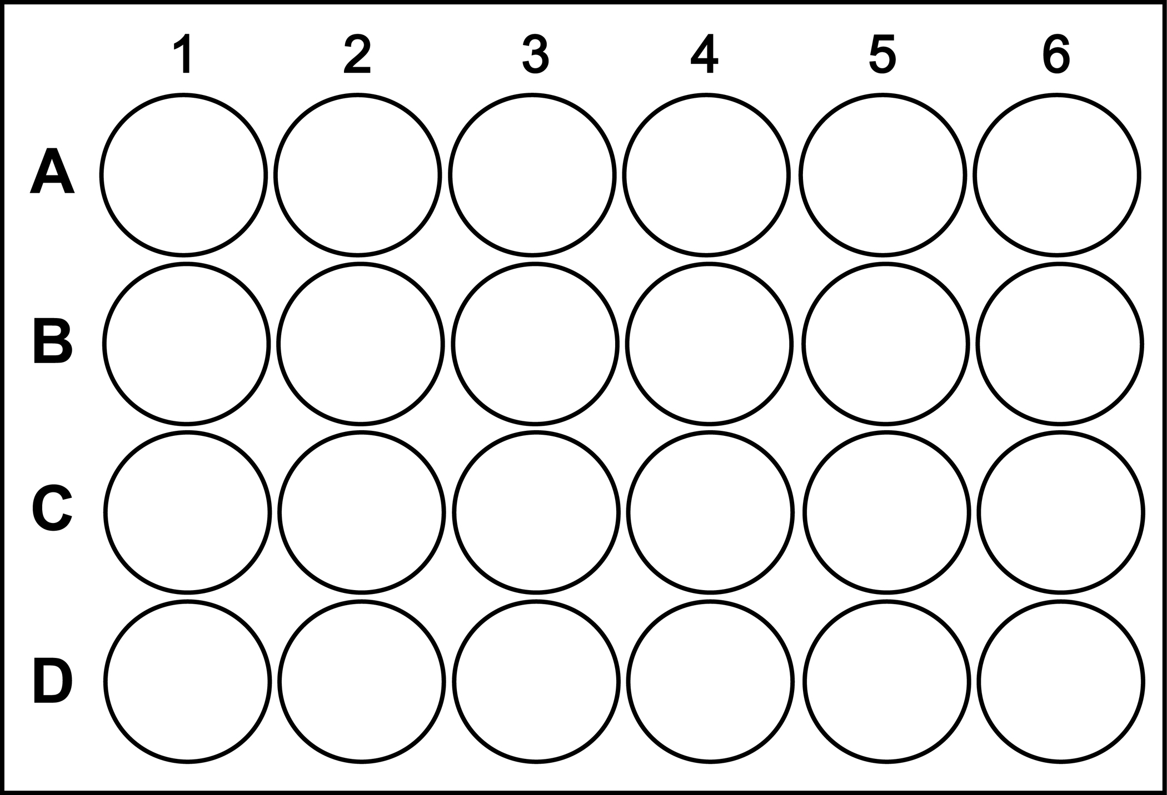

- Fill the three plastic cups about half full of water for pipette cleaning.
- In cell #1, place 10 drops of food coloring. This represents a pure substance, or a concentration of 1 million parts per million.
- Take one drop of the food coloring from cell #1 and place it in cell #2.
- Rinse the dropper in one of the plastic cups to remove all traces of food coloring.
- Add 9 drops of clean water to cell #2 and stir the mixture. The mixture is now diluted to 1/10th of the original concentration, or 100,000 parts food coloring per million parts of solution.
- Take one drop from cell #2 and place it in cell #3.
- Rinse the dropper again.
- Add 9 drops of clean water to cell #3 and stir the mixture. How concentrated is the food coloring now in ppms?
- Repeat the procedure for cells #4 to 10 (remember to clean the dropper between uses). After each dilution, record the new concentration in the cell in ppm.
Data Table (10 points)
 | Concentration
Cell Number | Fraction | Percentage | Parts per million | Parts per billion | Observation
1
2
3
4
5
6
7
8
9
10

Questions (2 points each)
- In which cell is the color most intense? Why? __________________________________________________
________________________________________________________________________________________________________________________________________________________________________________

- In which cell is the color least intense? Why? __________________________________________________
________________________________________________________________________________________________________________________________________________________________________________

- Are there any cells where the liquid is colorless? Is there any food coloring in these cells? How do you know?
________________________________________________________________________________________________________________________________________________________________________________________________________________________________________________________________________________________________________________________________________________________________
- Cell #1 contains food coloring with no water added. What is the percent concentration of food coloring in cell #1?

- 100 percent can be written as the fraction 100/100. Complete the following fraction so that both sides are equal:
100/100 = ____________________/1,000,000
- (3 points) The earth’s atmosphere contains 78% nitrogen and 21% oxygen. Write these percentages as concentrations in ppm.
78% = ___________/100 = ______________/1,000,000 = ______________ ppm

21% = ___________/100 = ______________/1,000,000 = ______________ ppm

- Which of your cells of food coloring is closest in concentration in ppm to nitrogen? Which cell is closest to the concentration of oxygen?

- (5 points) Carbon dioxide, methane, nitrous oxide, and chlorofluorocarbons (CFC’s) are greenhouse gases. Their concentrations are listed below. Which of your cells of food coloring is closest in concentration to the concentration of each gas? Convert the ppm concentrations to ppb.

Gas | Concentration | Cell Number
CO₂ | 355 ppm = ___________ ppb
CH₄ | 1.7 ppm = ___________ ppb
N₂O | 0.3 ppm = ___________ ppb
CFC-12 | 0.005 ppm = ___________ ppb
CFC-11 | 0.003 ppm = ____________ ppb

- How does the concentration of the greenhouse gases compare to the concentration of oxygen and nitrogen?
________________________________________________________________________________________________________________________________________________________________________________________________________________________________________________________________________________________________________________________________________________________________________________________________________________________________________________________

- How can gases such as carbon dioxide and methane, with their small concentrations, have such a large effect on our atmosphere?
________________________________________________________________________________________________________________________________________________________________________________________________________________________________________________________________________________________________________________________________________________________________________________________________________________________________________________________

