Conceptual Physics Name _______________________________
Milankovitch Cycles Block _______ Date ___________________

Part I - Scientist
Milutin Milankovitch (1879-1958) by Steve Graham • March 24, 2000
from https://earthobservatory.nasa.gov/Features/Milankovitch/
The Serbian astrophysicist Milutin Milankovitch is best known for developing one of the most significant theories relating Earth motions and long-term climate change. Born in 1879 in the rural village of Dalj (then part of the Austro-Hungarian Empire, today located in Croatia), Milankovitch attended the Vienna Institute of Technology and graduated in 1904 with a doctorate in technical sciences. After a brief stint as the chief engineer for a construction company, he accepted a faculty position in applied mathematics at the University of Belgrade in 1909—a position he held for the remainder of his life.

Milankovitch dedicated his career to developing a mathematical theory of climate based on the seasonal and latitudinal variations of solar radiation received by the Earth. Now known as the Milankovitch Theory, it states that as the Earth travels through space around the sun, cyclical variations in three elements of Earth-sun geometry combine to produce variations in the amount of solar energy that reaches Earth:

- Variations in the Earth's orbital eccentricity—the shape of the orbit around the sun.
- Changes in obliquity—changes in the angle that Earth's axis makes with the plane of Earth's orbit.
- Precession—the change in the direction of the Earth's axis of rotation, i.e., the axis of rotation behaves like the spin axis of a top that is winding down; hence it traces a circle on the celestial sphere over a period of time.

Together, the periods of these orbital motions have become known as Milankovitch cycles.

Orbital Variations
Changes in orbital eccentricity affect the Earth-sun distance. Currently, a difference of only 3 percent (5 million kilometers) exists between closest approach (perihelion), which occurs on or about January 3, and furthest departure (aphelion), which occurs on or about July 4. This difference in distance amounts to about a 6 percent increase in incoming solar radiation (insolation) from July to January. The shape of the Earth’s orbit changes from being elliptical (high eccentricity) to being nearly circular (low eccentricity) in a cycle that takes between 90,000 and 100,000 years. When the orbit is highly elliptical, the amount of insolation received at perihelion would be on the order of 20 to 30 percent greater than at aphelion, resulting in a substantially different climate from what we experience today.
The eccentricity of the Earth's orbit changes slowly over time from nearly zero to 0.07. As the orbit gets more eccentric (oval) the difference between the distance from the Sun to the Earth at perihelion (closest approach) and aphelion (furthest away) becomes greater and greater. Note that the Sun is not at the center of the Earth's orbital ellipse, rather it is at one of focal points.
Note: The eccentricty of the orbit shown in the lower image is a highly exaggerated 0.5. Even the maximum eccentricity of the Earth's orbit—0.07—it would be impossible to show at the resolution of a web page. Even so, at the current eccentricity of .017, the Earth is 5 million kilometers closer to Sun at perihelion than at aphelion. (Images by Robert Simmon, NASA GSFC)

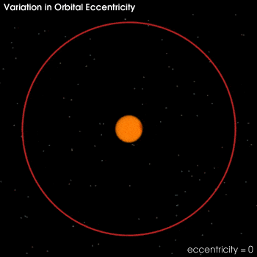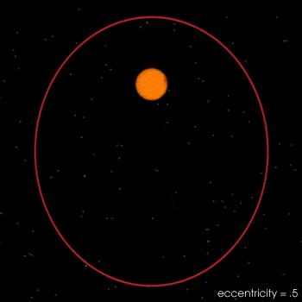

Obliquity (change in axial tilt)
As the axial tilt increases, the seasonal contrast increases so that winters are colder and summers are warmer in both hemispheres. Today, the Earth's axis is tilted 23.5 degrees from the plane of its orbit around the sun. But this tilt changes. During a cycle that averages about 40,000 years, the tilt of the axis varies between 22.1 and 24.5 degrees. Because this tilt changes, the seasons as we know them can become exaggerated. More tilt means more severe seasons—warmer summers and colder winters; less tilt means less severe seasons—cooler summers and milder winters. It's the cool summers that are thought to allow snow and ice to last from year-to-year in high latitudes, eventually building up into massive ice sheets. There are positive feedbacks in the climate system as well, because an Earth covered with more snow reflects more of the sun's energy into space, causing additional cooling.

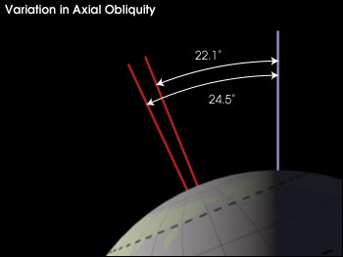
The change in the tilt of the Earth's axis (obliquity) effects the magnitude of seasonal change. At higher tilts the seasons are more extreme, and at lower tilts they are milder. The current axial tilt is 23.5°. Image by Robert Simmon, NASA GSFC)

Precession
Changes in axial precession alter the dates of perihelion and aphelion, and therefore increase the seasonal contrast in one hemisphere and decrease the seasonal contrast in the other hemisphere.
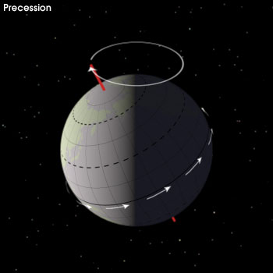

Precession—the change in orientation of the Earth's rotational axis [this can be seen more clearly in an animation (small (290 kB QuickTime) or large (1.2 MB QuickTime))]—alters the orientation of the Earth with respect to perihelion and aphelion. If a hemisphere is pointed towards the sun at perihelion, that hemisphere will be pointing away at aphelion, and the difference in seasons will be more extreme. This seasonal effect is reversed for the opposite hemisphere. Currently, northern summer occurs near aphelion. (Image by Robert Simmon, NASA GSFC)

Using these three orbital variations, Milankovitch was able to formulate a comprehensive mathematical model that calculated latitudinal differences in insolation and the corresponding surface temperature for 600,000 years prior to the year 1800. He then attempted to correlate these changes with the growth and retreat of the Ice Ages. To do this, Milankovitch assumed that radiation changes in some latitudes and seasons are more important to ice sheet growth and decay than those in others. Then, at the suggestion of German Climatologist Vladimir Koppen, he chose summer insolation at 65 degrees North as the most important latitude and season to model, reasoning that great ice sheets grew near this latitude and that cooler summers might reduce summer snowmelt, leading to a positive annual snow budget and ice sheet growth.
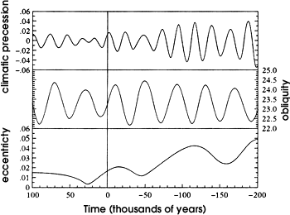
But, for about 50 years, Milankovitch's theory was largely ignored. Then, in 1976, a study published in the journal Science examined deep-sea sediment cores and found that Milankovitch's theory did in fact correspond to periods of climate change (Hays et al. 1976). Specifically, the authors were able to extract the record of temperature change going back 450,000 years and found that major variations in climate were closely associated with changes in the geometry (eccentricity, obliquity, and precession) of Earth's orbit. Indeed, ice ages had occurred when the Earth was going through different stages of orbital variation.
Since this study, the National Research Council of the U.S. National Academy of Sciences has embraced the Milankovitch Cycle model.
...orbital variations remain the most thoroughly examined mechanism of climatic change on time scales of tens of thousands of years and are by far the clearest case of a direct effect of changing insolation on the lower atmosphere of Earth (National Research Council, 1982).

Questions
- In his research, Milankovitch studied earth’s orbit. What were the three ideas about earth’s orbit that he looked closely at? (1 pt.)
  - _________________________________________________________________
  - _________________________________________________________________
  - _________________________________________________________________

- After reading the article, define the following terms. (3 pts.):
  - Eccentricity:__________________________________________________________________________
____________________________________________________________________________________
  - Obliquity:____________________________________________________________________________
____________________________________________________________________________________
  - Precession:___________________________________________________________________________
____________________________________________________________________________________

Part II - Simulation
- Now go to the website: http://cimss.ssec.wisc.edu/climatechange/observations/lesson6/earthorbit.html This is a website that shows how the earth orbits the sun, and lets you see the factors that Milankovitch studied. The data used to create this was taken from ice core samples that show the Earth’s temperature over the last 400,000 years.

- Click on the button “Show Top View”. This will show you earth’s orbit from above. Observe how earth moves about the sun and the information the animation provides. The summer solstice is at the aphelion of earth’s orbit. The winter solstice is at the perihelion of earth’s orbit. Watch the video closely and try to determine what aphelion and perihelion mean. (1 pt.)

  - At aphelion, the earth is ____________________ the sun.
(closer to, farther from)

  - At perihelion, the earth is ____________________ the sun.
(closer to, farther from)

- Now click the button “Show Side View”. This will show you a view of how the earth is titled on its axis as it orbits the sun. Use this view to answer the following questions. (1 pt.)

  - The tilt of the earth is _______________________________during the aphelion.
(toward the sun, away from the sun)

  - The tilt of the earth’s axis is ____________________________ during the perihelion.
(toward the sun, away from the sun)

- Apply: Summarize how the tilt of the earth and its orbit determine the amount of solar radiation (sun’s rays) that we get here in Connecticut. Use the terms aphelion and perihelion in your answer, and describe how it changes over the course of one revolution. (2 pts.)
____________________________________________________________________________________________________________________________________________________________________________________________________________________________________________________________________________________________________________________________________________________________________________________________________________________________________________________________________________________________________________________________________________________________________________________

- During his studies, Milankovitch found that the amount of solar radiation (sun’s rays) changes during the seasons and also at different latitudes (how far north or south you are from the equator). This was also seen in the ice core samples that they studied in Antarctica.

Looking at the simulation on the computer, there is a graph on the right that shows the average temperature on Antarctica over the last 400,000 years. Look at that graph and briefly describe the changes in the temperature during that time. (2 pts.)
_________________________________________________________________________________________________________________________________________________________________________________________________________________________________________________________________________________________________________________________________________________________________________________________________________________________________________________________________________________________________________________________________________________________________________________________________________________________________________________________________________________

  - During the 400,000 years shown in the graph, how many temperature cycles do you count? (1 pt.) __________

  - (T/F) The temperature now (present day) is the warmest temperature found in the ice core samples. (1 pt.) _____

- Click on the both the “Eccentricity” and the “Show Top View” buttons on the bottom of the screen. This places a purple line on the graph to the right that shows how the shape of earth’s orbit changes over time. On the top left of this graph is an arrow that you can slide up and down to see how the eccentricity of the orbit changes over time. Slide it up and down and observe how the orbit changes.

Look at the purple line on the graph. Does the way it goes up and down look similar to (correlate) the way the temperature goes up and down? (1 pt.) _______

- Unclick the “Eccentricity” button and click the “Precession” button at the bottom of the screen. This places a purple line on the graph that shows how the tilt of earth “wobbles” over time. Again, slide the arrow on the graph up and down to see how the tilt of earth’s axis wobbles.

The purple line on the graph that shows the precession has ____________ peaks and valleys than the temperature graph. (1 pt.) (more, less)

- Unclick the “Precession” button and click the “Tilt” button at the bottom of the screen. This places a purple line on the graph that shows how the tilt of earth changes over time. Again, slide the arrow on the graph up and down to see how the tilt of earth’s axis changes.

Looking at the purple line on the graph, the tilt of earth has _______________________ peaks and valleys on it. This suggests that the tilt of the earth _____________________. (1 pt.) (regular, irregular)
(change, does not change)

- Leave the “Tilt” button clicked and also click the “Eccentricity” and the “Precession” buttons. This will display a purple line that shows the effect of all three changes. Compare the purple line to the temperature graph.

Of all the purple lines you have looked at, does this new line that includes all three factors ____________________ relate to the temperatures over the last 400,000 years. (1 pt.) (more closely, less closely)

- Milankovitch studied the relationship between eccentricity, precession, tilt, and the temperature on earth. He believed that all three had an impact on the climate because they affected the amount of sunlight on earth. Other people have since collected data from ice cores in Antarctica. Does this new data support his theory or not. How does this data either support Milankovitch or prove him wrong. Explain your answer. (2 pts.)
________________________________________________________________________________________________________________________________________________________________________________________________________________________________________________________________________________________________________________________________________________________________________________________
__________________________________________________________________________________________________________________________________________________________________________________________________________________________________________________________________________________________________________________________________________________________________________________________________________________________________________________________________________________________________________________________________________________________________________________________________________________________________________________________________________________

